1. AIM TO: Design DFA using simulator to accept even number of a’s.

INPUT:

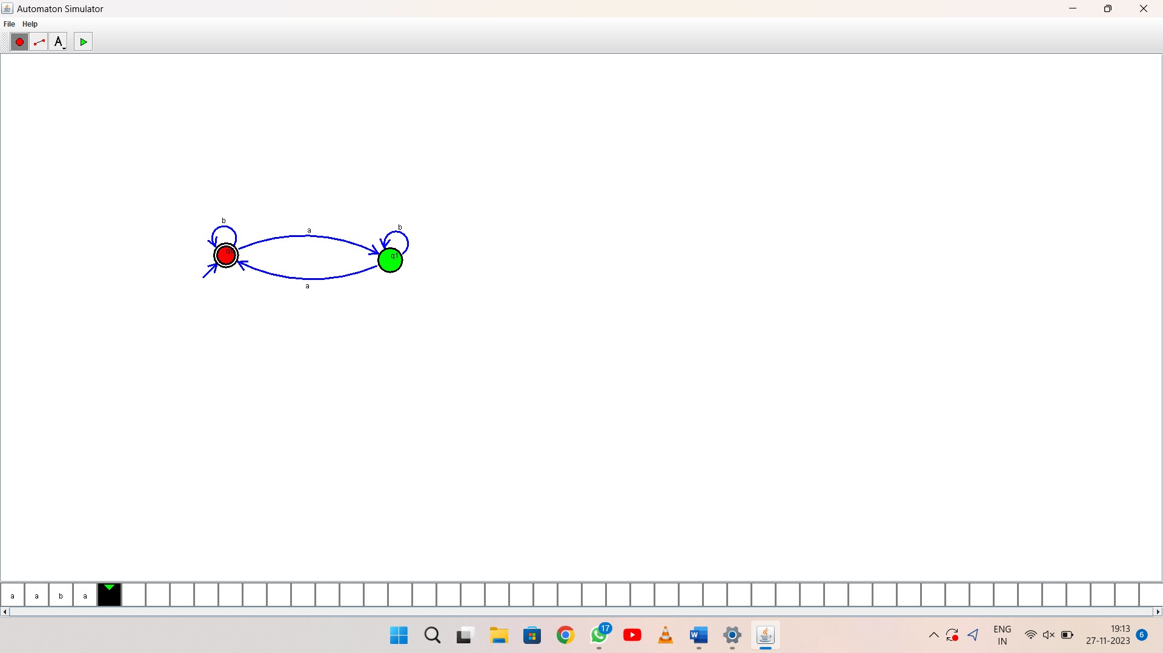

OUTPUT:

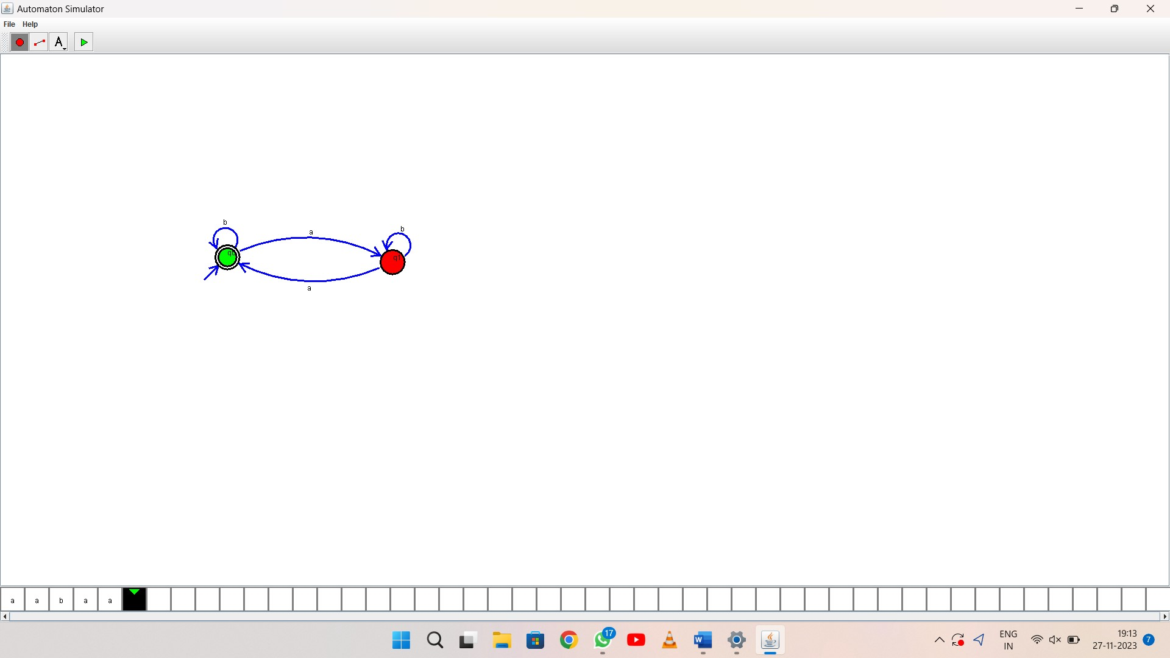

1. RESULT: thus Design DFA using simulator to accept even number of a’s.